|  |  |
| --- | --- |
| **Name:** | MANSI UNIYAL |
| **Roll Number:** | 19EE10039 |

**Experiment No. 3**

**Name of the Experiment: Half Wave Rectification**

1. **Aim of the experiment**

Explain the working of a Half Wave Rectifier

1. **Tools used:**

* Stimulation: Vlabs
* P-N junction diode
* CRO (cathode ray oscilloscope)
* Sinusoidal input voltage source
* Resistance
* Connecting Wires

1. **Background knowledge (brief):**
   * Rectification
     + A rectifier is a device that converts alternating current (AC) to direct current (DC), a process known as rectification. Rectifiers are essentially of two types – a half wave rectifier and a full wave rectifier.
   * Half Wave Rectification
     + On the positive cycle the diode is forward biased and on the negative cycle the diode is reverse biased. By using a diode, we have converted an AC source into a pulsating DC source. In summary we have ‘rectified’ the AC signal.
     + The half-wave rectifier is a circuit that allows only part of an input signal to pass. The circuit is simply the combination of a single diode in series with a resistor, where the resistor is acting as a load.

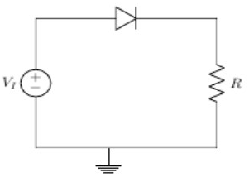 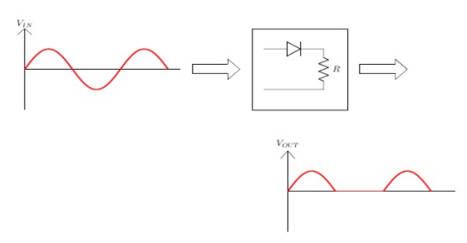

**Half Wave Rectifier**

* + 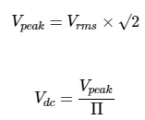Half Wave Rectifiers – Waveforms
    - The output DC voltage of a half wave rectifier can be calculated with the following two ideal equations.
  + Half Wave Rectification: For **Positive Half** Cycle
    - Diode is forward biased, acts as a **short circuit**, passes the waveform through.

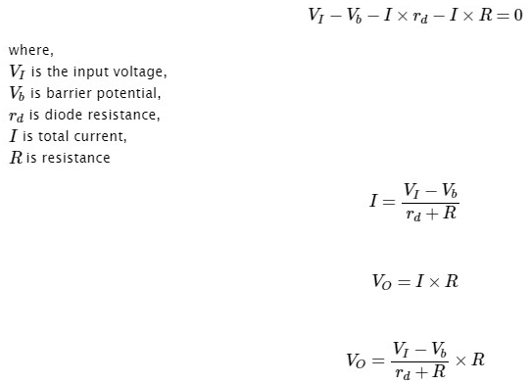

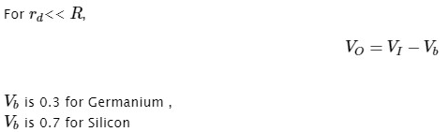

CASE 1

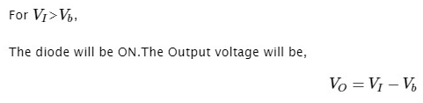

CASE 2

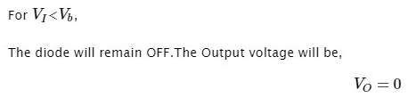

* Half Wave Rectification: For **Negative** Half Cycle
  + Diode is reverse biased, acts as an **open circuit**, does not pass the waveform through.



* For ideal diode



* For positive cycle



* For negative cycle



* Average output voltage

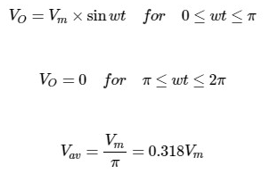

* RMS load voltage



* Average load current

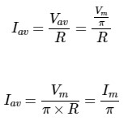

* RMS load current



* Form factor

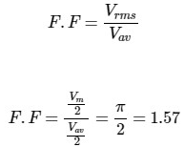

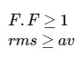

* Ripple factor

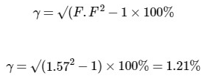

* Efficiency

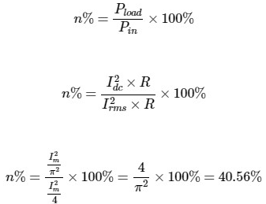

* Peak inverse voltage
  + The maximum value of reverse voltage which occurs at the peak of the input cycle when the diode is reverse-biased.

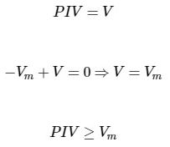

1. **Circuit (hand drawn/image)**

* Resistance (200ohms)

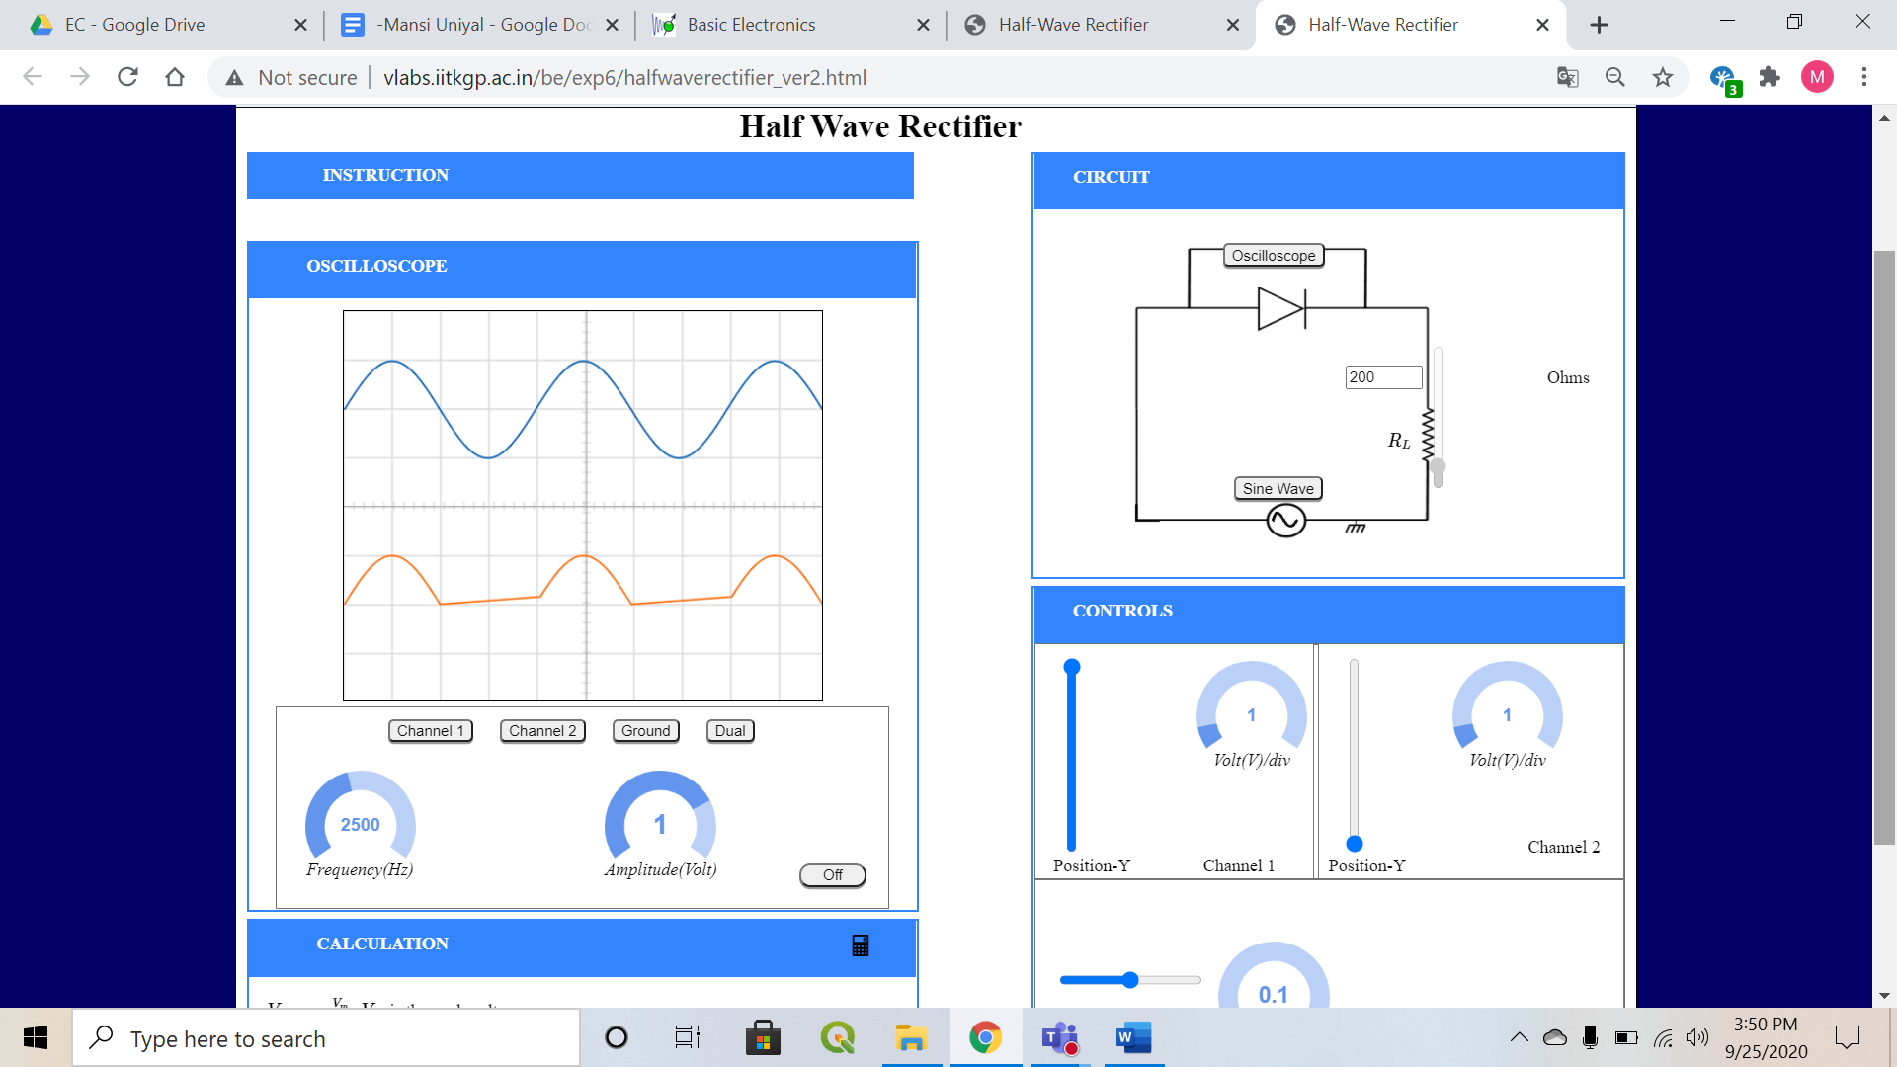

* Resistance (400ohms)

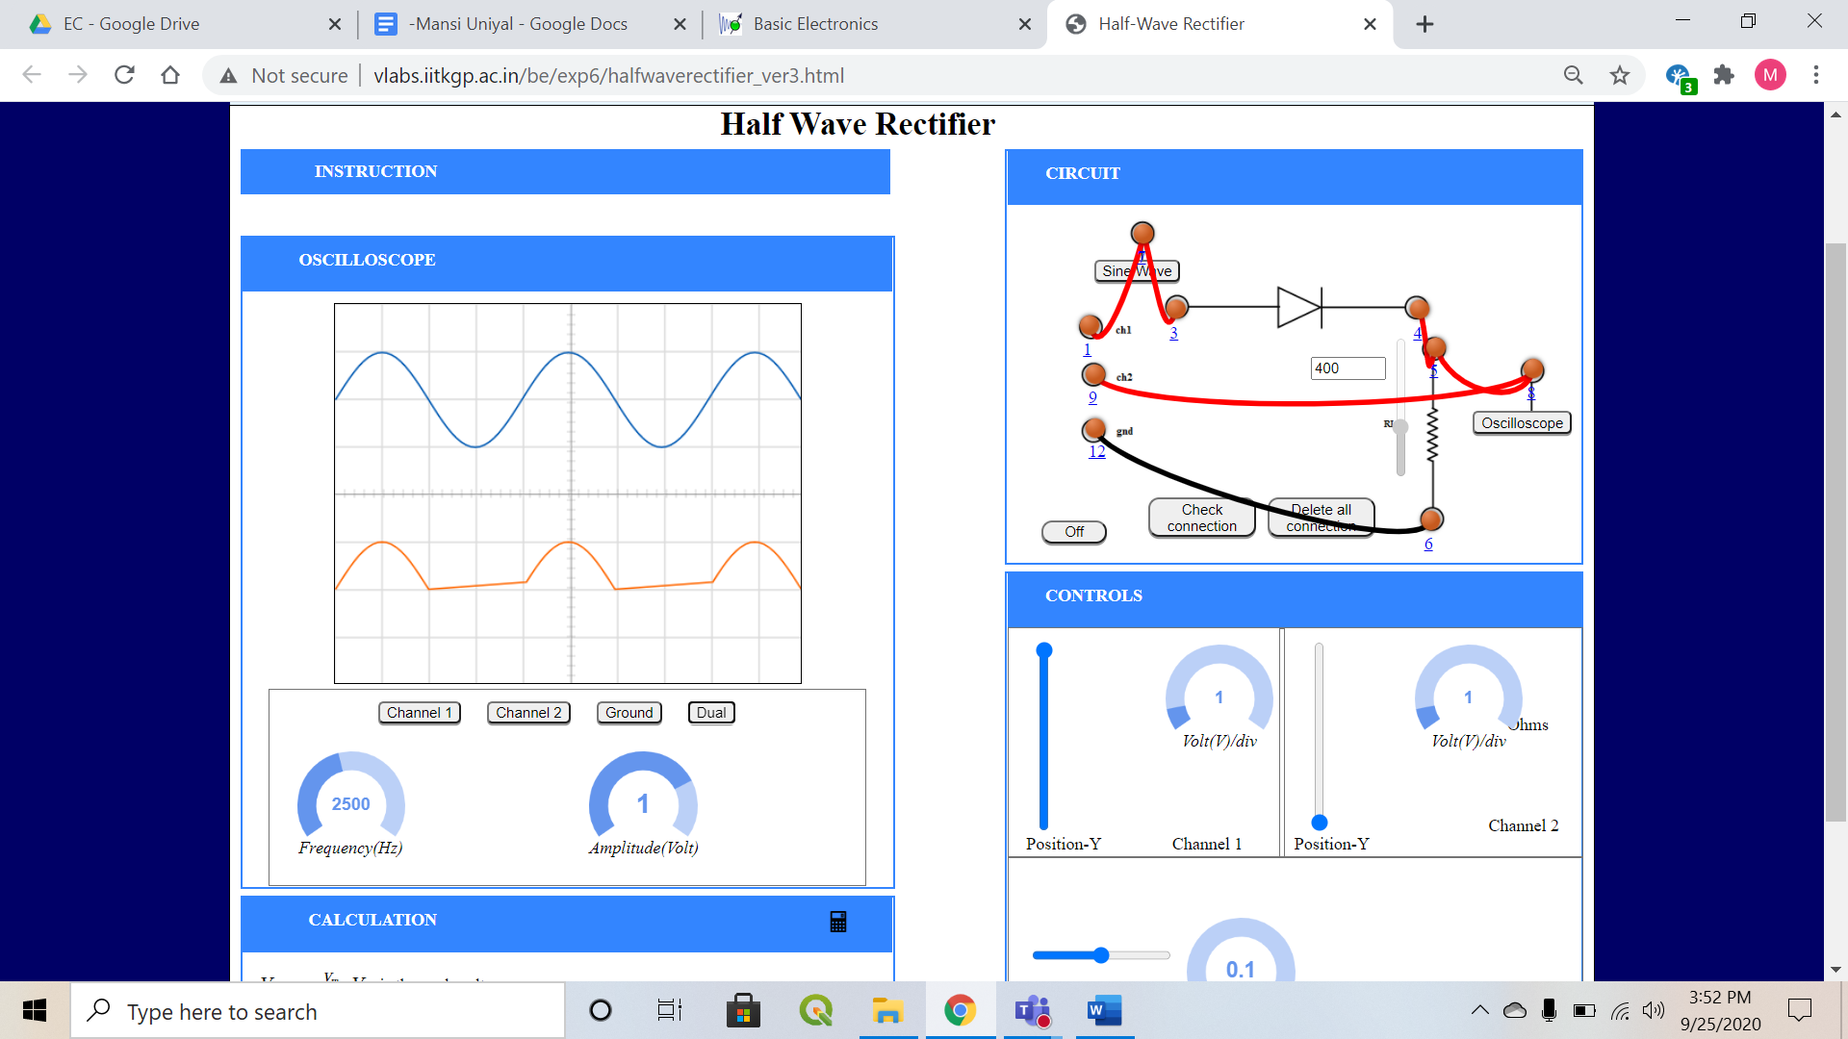

1. **Measurement Data (Tabular form)**

* Resistance (200ohms)

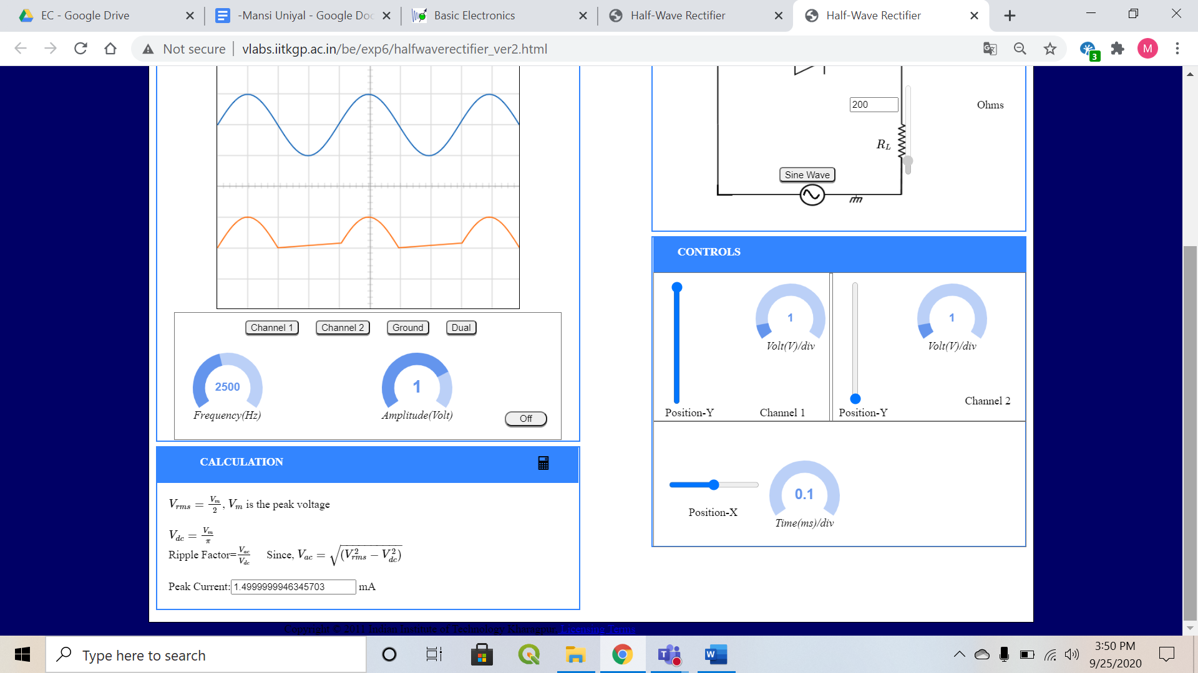



* Resistance (400ohms)

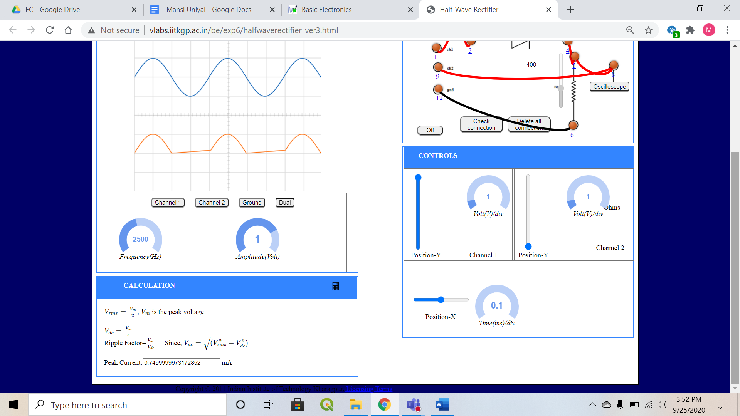



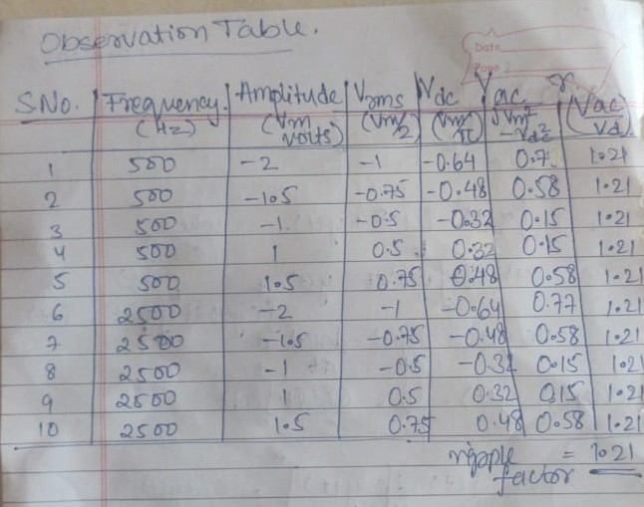

However, both the different peak values of current and different values of series resistance we get the same value for the ripple factor (40.56 %).

1. **Graph (Image)/Screenshots**

* Resistance (200ohms)



Sinusoidal input signal

Output rectified signal

* Resistance (400ohms)



Sinusoidal input signal

Output rectified signal

1. **Conclusion**
   * + Rectification is the conversion of alternating current to direct current.
     + Half Wave rectifier passes only half of the incoming AC power supply.
     + Value of ripple factor doesn’t depend on peak current value nor the series resistance value.
     + Ripple factor for Half Wave Rectifier is 40.56 %.
2. **Discussions**
3. **Advantages** of Half Wave Rectifier
   1. Simple with low number of components.
   2. Cheap, cost effective. However, over period of time there is more power loss, so more costly.
4. **Disadvantages** of Half Wave Rectifier
   1. They only allow a half-cycle through per sinewave, and the other half-cycle is wasted. This leads to power loss.
   2. They produce a low output voltage.
   3. The output current we obtain is not purely DC, and it still contains a lot of ripple (i.e. it has a high ripple factor)
5. **Quiz**

